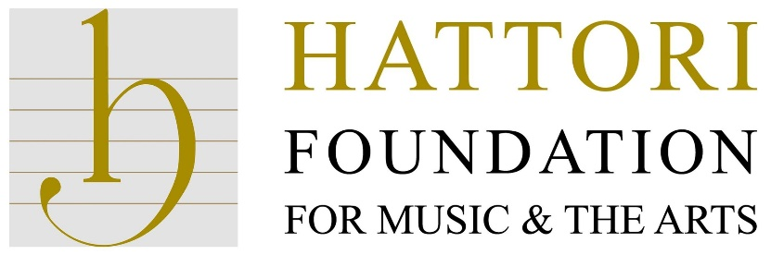
Junior award application pack 2021-2022
Deadline ongoing
Thank you very much for your interest in applying for a Hattori Foundation Junior award.

The Trustees of the Hattori Foundation invite instrumental soloists between the ages of 15 and 20 who are resident in the UK and have demonstrated both exceptional talent and achievement to apply at any time of the year for financial assistance in relation to their musical development.

Before filling out the application form please make sure you read through the following information.

JUNIOR AWARDS:

Awards are available for: |  | assistance to attend masterclasses in the UK or abroad (including travel costs)
 |  | assistance to attend national or international competitions (including travel costs)
 |  | specific assistance in the case or hardship

Awards are not available for: |  | conductors, singers, or composers
 |  | the repair or purchase of instruments
 |  | tuition fees for full-time study
 |  | expenses incurred prior to the application
 |  | orchestral courses

Junior Awards are granted up to a maximum of £1,000.
Awards for costs to attend/participate in masterclasses or competitions may depend on successfully being granted a place to participate/compete.
A successful Junior Award grant may not cover the total amount of costs specified.

GENERAL CRITERIA:

Applicants must demonstrate exceptional talent.
They must provide evidence of public recital or concerto performances within the preceding 2 years together with an upcoming project proposal.
All applicants must be British citizens, Foreign Nationals normally resident in the UK, or Foreign Nationals who are studying full-time in the UK.
Applicants should be 15 to 20 years of age at the date of application.
Applications must be supported by two referees who should be professional musicians.

APPLICATION / AUDITIONS PROCESS:

Applicants should submit the following items to the Hattori Foundation
via email admin@hattorifoundation.org.uk
or post 7 Exton Street, London SE1 8UE

Completed application form, including all information requested
A recording (video, or audio only)
- minimum 30 minutes in duration
- include at least 3 contrasting works from different periods.
The recordings should include at least one work composed before 1850 (including transcriptions of those works) - exceptions apply to instruments for which no solo works were composed before 1850, e.g. trombone, accordion.
- recordings must have been made within 6 months of the application. The submissions may be compiled from different recordings within the last 6 months.
- may be submitted by links to online recordings (a created YouTube playlist is ideal), or by CD/DVD.
- Please don’t apply filters to your sound to make it sound like it comes from a hall if it’s recorded in your home. The Trustees will be able to assess your musicianship and skill from the ‘raw’ recordings.
Two references (in the format provided) supporting your application
- one from your current teacher, and
- one from a prominent musician.
References should be submitted directly by your referee by email or post.

You may be invited for an audition and personal interview with the Artistic Director, after which you will be advised of the Hattori Foundation’s decision.

Please allow at least 2 months for your application to be processed.

ALL applicants will be notified in writing as to the outcome of their application.

Applicants must not contact any trustee regarding their application.
Any such approach would disallow their application.

All correspondence and completed application forms and references should be sent to Glenn Kesby:

admin@hattorifoundation.org.uk

Or

Hattori Foundation
7 Exton Street
London SE1 8UE
Telephone: 020 7620 3053

We wish you all the best with your application.

Yours sincerely,

Glenn Kesby,
General Manager

JUNIOR AWARD APPLICATION FORM 2021-22

Full name (first name / last name)
Instrument
Date of birth (DD-MM-YYYY) |  | Age at submission
Nationality
(Non-British applicants: date when permanent UK residency began)
Email address*
Telephone number*
Address for correspondence*

* Applicants under the age of 18
If the applicant is under the age of 18 the application form should be completed by their Parent/Guardian

Name of Parent/Guardian
(if applicant under 18 years)

I give consent for my child to be considered for a Junior Award and understand
recordings will be shared as necessary with panel members.

In which category are you are applying for assistance: (tick all that apply)
assistance to attend masterclasses in the UK or abroad
(including travel costs)
assistance to attend national or international competitions
(including travel costs)
specific assistance in the case or hardship

Full details of the project you are applying for assistance with, whether you have yet been offered a place on the masterclass or competition, together with an indication of all costs involved (attach further details if more space is required)

RECORDINGS

(minimum 30 minutes) of at least 3 contrasting works from different periods. Recordings must have been made within 6 months of the application deadline.
(See notes for further details of requirements).

Recording 1
Composer
Title of piece
Link
Duration

Recording 2
Composer
Title of piece
Link
Duration

Recording 3
Composer
Title of piece
Link
Duration

If more than 3 works submitted to meet duration requirement…

Recording 4
Composer
Title of piece
Link
Duration

(attach further details if more space is required)

BIOGRAPHY / C.V.

Please insert or attach your biography or C.V. which should include the following information:
- the age at which your music studies commenced
- a list of teachers in the UK and abroad and date of study with each
- a list of examinations taken (if any) with dates and results
- name, date and result of any national or international competition in which you have competed
- details of solo concert experience within the last 2 years and of future solo engagements both confirmed and unconfirmed

(attach further details if more space is required)
REFERENCES

Your application should be supported by two referees. It is expected that one would be from your current (or recent) teacher, and the other from a prominent musician.

Name of Referee No.1
Name of Referee No.2

Please ask your referees to send their reference directly to Glenn Kesby, general manager of the Hattori Foundation;

by email: admin@hattorifoundation.org.uk
or by post: 7 Exton Street, London SE1 8UE

Each reference should cover the following points:

- Applicant’s name
- Referee’s name
- What is your relationship to the applicant?
- How long have you known the applicant?
- When did you last hear the applicant perform in public?
- Do you consider that the applicant has exceptional soloistic talent and do their achievements show the possibility of an international career?
- Any remarks you feel may be useful to the Hattori Foundation trustees in assessing the applicant’s submission.

Completed application forms should be sent to:
The General Manager
Hattori Foundation
7 Exton Street
London SE1 8UE
Email: admin@hattorifoundation.org.uk

Telephone: 020 7620 3053

